DATE AND TIME FUNCTIONS
Input:

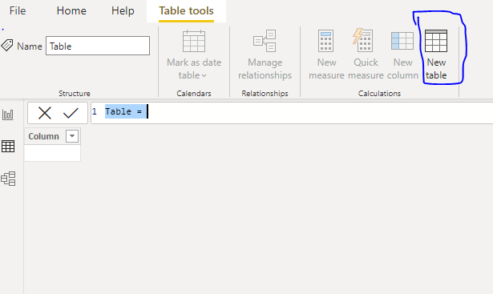

1)CALENDAR: To generate a date between the start date and end.
Syntax: CALENDAR(<start_date>, <end_date>)
NOTE: In this mention Dynamic values also.
Dax Function: Calendar=CALENDAR ("2022-05-01","2022-05-15")
Output:
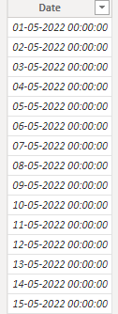

2)DATE: Returns the specified date in datetime format.
Syntax: DATE(<year>, <month>, <day>)
Dax Function: Date1=DATE(2022,05,15)
Output:
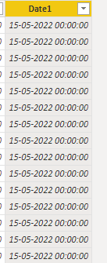
3) DATEDIFF: Returns the diff between two dates based on interval boundaries such as Hour, Minute, Second, Year, Week, Quarter and Month.
Syntax: DATEDIFF(<start_date>, <end_date>, <interval>)
Dax Function: DateDiff=DATEDIFF('Calendar'[Date],'Calendar'[Date1],DAY)
Output:
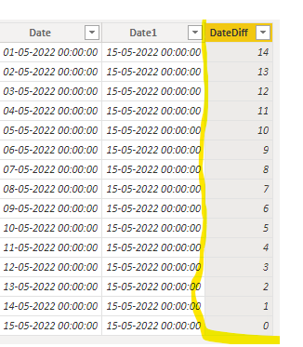
4)DATEVALUE: Converts a date in text format to a datetime format.
Syntax: DATEVALUE (date_text)
Dax function: Datevalue = DATEVALUE('Calendar'[Date1])
Output:
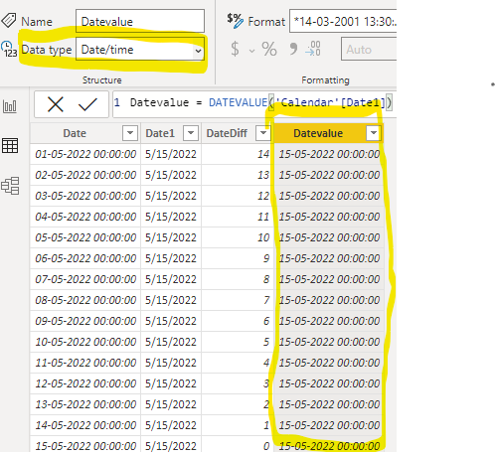
5)DAY: Extract the day from the Date column.
Syntax: DAY(<date>)
Dax Function: Day=DAY('Calendar'[Datevalue]
Output: 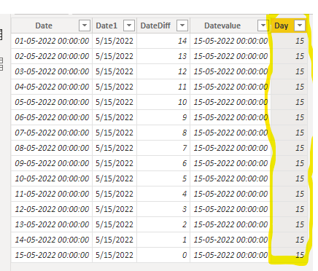

6)EDATE: Returns the date that is indicated number of months before or after the start date.
Syntax: EDATE(<start_date>, <months>)
NOTE: In this definition, before means negative values, after means positive values are mentioned.
Dax Function: Edate=EDATE('Calendar'[Datevalue],2)
Output: 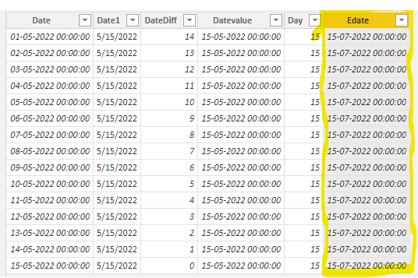

7)EOMONTH: Returns the date of the last day of the month before or after the specified number of months.
Syntax: EOMONTH(<start_date>, <months>)
Dax Function: EoMonth=EOMONTH('Calendar'[Datevalue],2)
Output: 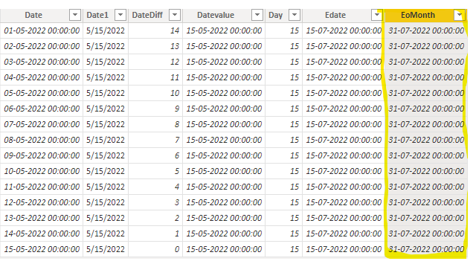

8)Now: Returns the current date and time in Datetime format.
Syntax: NOW()
Dax Function: Now=NOW()
Output:
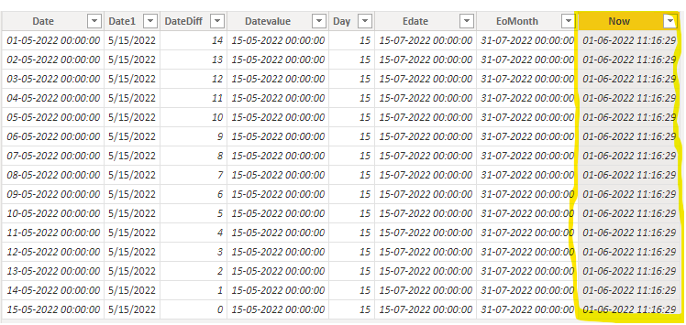
9)TODAY : Returns the current date.
Syntax: TODAY()
Dax Function: Today=TODAY()
Output :
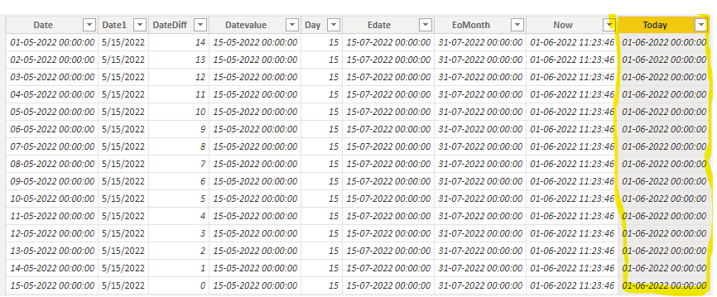

10)Hour: Extract the Hour component from Datetime column.
Syntax: HOUR(<datetime>)
Dax Function: Hour = HOUR('Calendar'[Now])
Output:
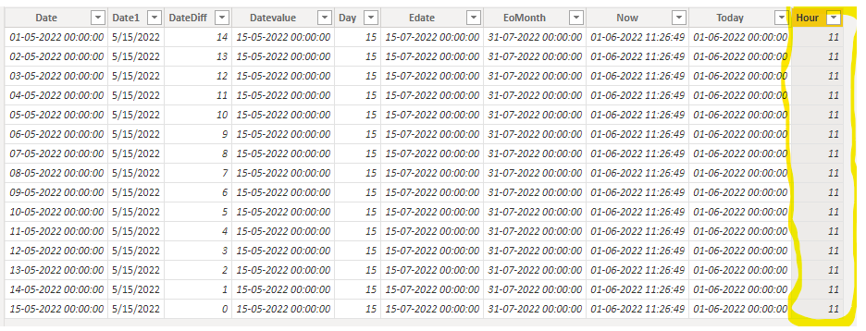
11)MINUTE: Extract the minute component from Datetime column.
Syntax: MINUTE(<datetime>)
Dax Function: Minute = MINUTE('Calendar'[Now])
Output:
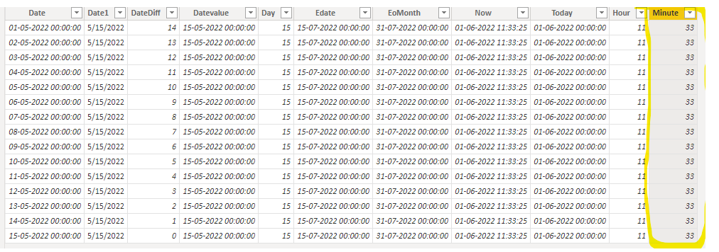

12)TIME: Extract hours, minutes and seconds from datetime column.
Syntax: TIME (hour, minute, second)
Dax Function: Time=TIME(HOUR('Calendar'[Now]),MINUTE('Calendar'[Now]),SECOND('Calendar'[Now]))
Output:
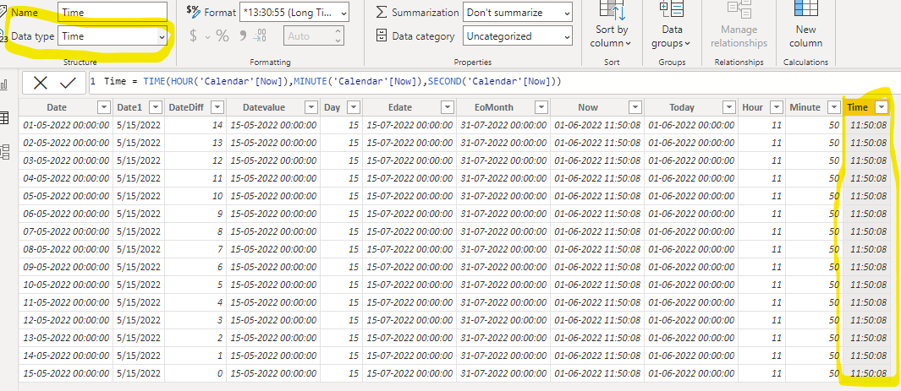
13)SECOND: Extract the second component from the time column.
Syntax: SECOND(<time>)
Dax Function: Second=SECOND('Calendar'[Time])
Output:
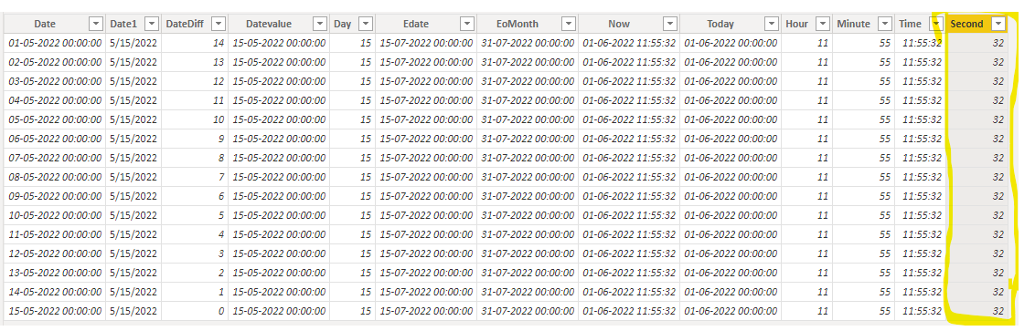

14)MONTH: Extract the month component from datetime column.
Syntax: MONTH(<datetime>)
Dax Function: Month= MONTH('Calendar'[Today])
Output:
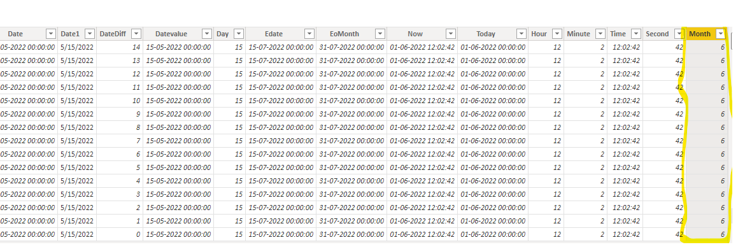
15)QUARTER: Extract the Quarter component from datetime column.
Syntax: QUARTER(<date>)
Dax Function: Quarter=QUARTER('Calendar'[Today])
Output :
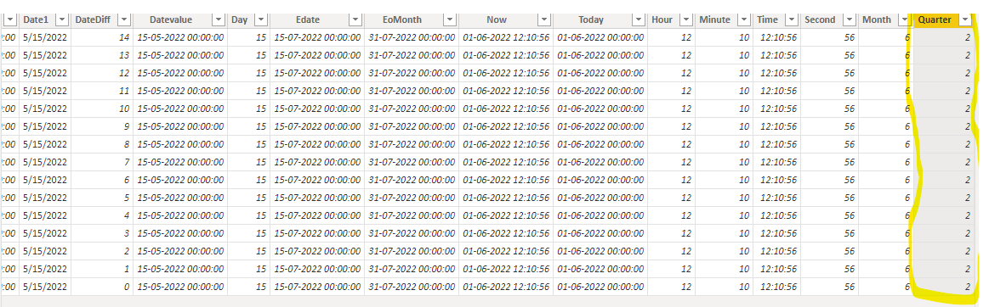
16)YEAR: Extract the Year component from Datetime column.
Syntax: YEAR(<date>)
Dax Function: Year=YEAR('Calendar'[Today])
Output:
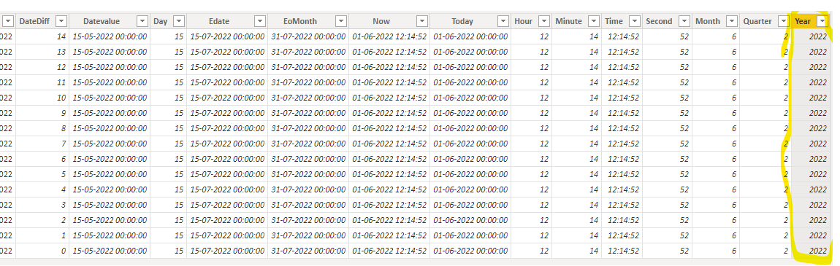
17)TIMEVALUE: Converts a time in text format to a time format.
Syntax: TIMEVALUE(time_text)
Dax Function: Timevalue=TIMEVALUE('Calendar'[Time])
Output:
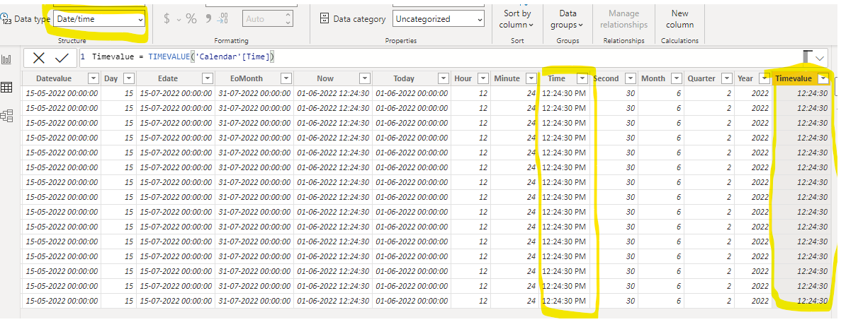
18)WEEKDAY: Returns the day of the week according to the return type value.
NOTE: Return type: 1, week begins on Sunday (1) and ends on Saturday (7).
Return type: 2, week begins on Monday (1) and ends on Sunday (7).
Return type: 3, week begins on Monday (0) and ends on Sunday (6).

Syntax: WEEKDAY(<date>, <return_type>)
Dax Function: Weekday = WEEKDAY('Calendar'[Today],2)
Output: 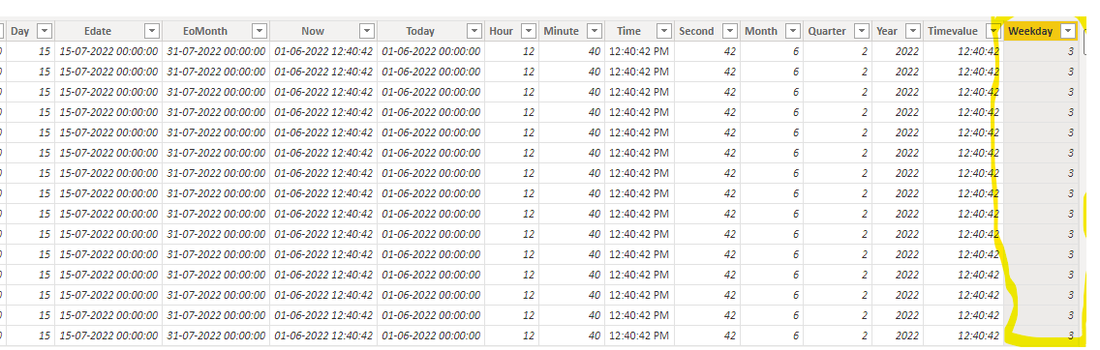

19)WEEKNUMBER: Returns week number of the given date according to the return type value such as 1 or 2.
Syntax: WEEKNUM(<date>, <return_type>])
NOTE:
Return 1 - The week containing January 1 is the first week of the year and is numbered week 1.
Return 2 - The week containing the first Thursday of the year is the first week of the year and is numbered as week 1

Dax Function: Weeknumber = WEEKNUM('Calendar'[Today],1)
Output: 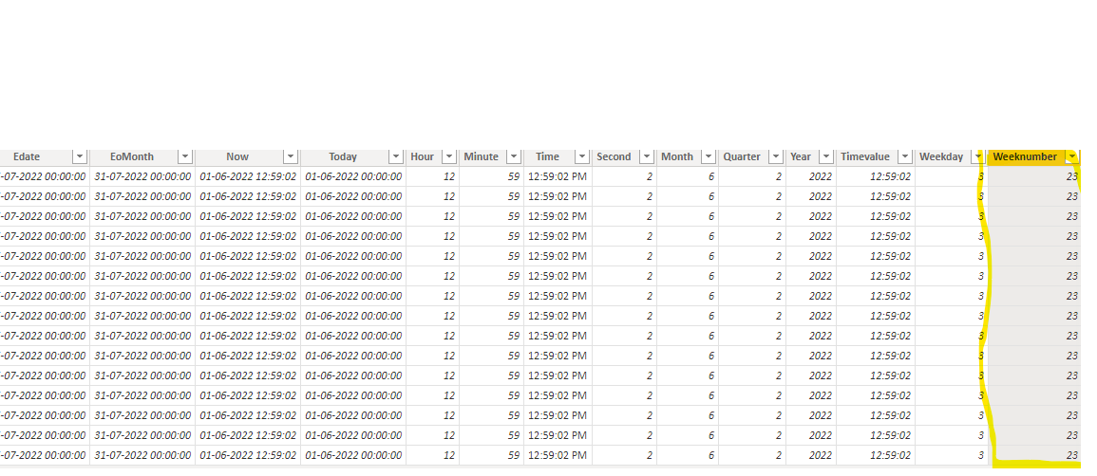

20)UTCNOW: Return the UTC current date and time.
Syntax: UTCNOW ()
Dax Function: Utc=UTCNOW()
Output: 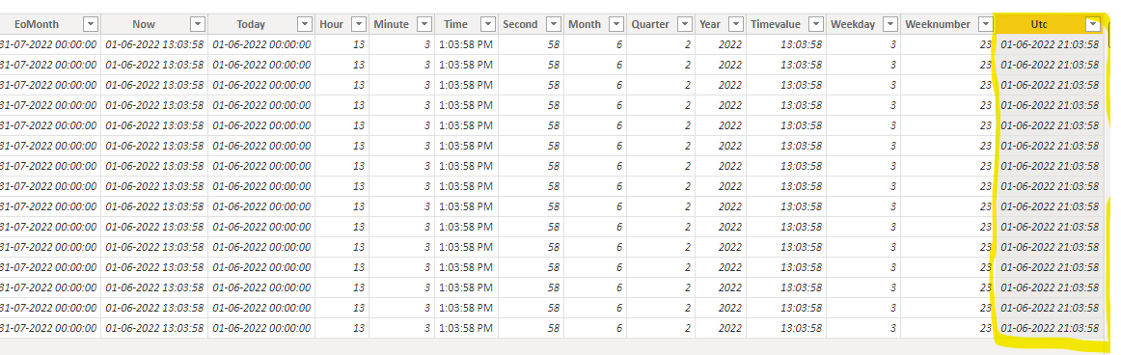
21)UTCTODAY : Returns the UTC current date.
Syantx : UTCTODAY()
Dax Function : Utctoday=UTCTODAY()
Output: 